Introduction to CHEMICAL EQUILIBRIUM
When a reaction takes place in both the forward and reverse directions, it is said to be reversible. Reversible reactions can reach a stage where the concentrations of both reactants and products remains constant – this is referred to as a chemical equilibrium.
Equilibrium in Chemical Reactions
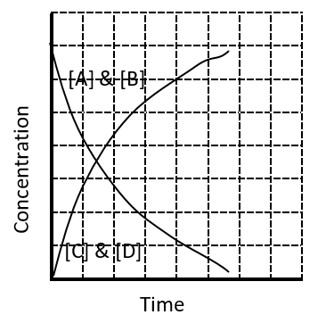
Consider the following generic chemical equation:
A + B → C + D
At the beginning of the reaction, only the reactants A and B are present. Recall that over the course of a reaction, the reaction rate slows down. This is because the rate depends on the concentrations of one or more reactants. As the reactants are used up, their concentrations drop, thus decreasing the reaction rate.

Up until this point, we have written the equations for chemical reactions in a way that would seem to indicate that all reactions proceed until all of the reactants have been converted into products. In reality, a great many chemical reactions do not proceed entirely to completion. A reversible reaction is a reaction in which the conversion of reactants to products and the conversion of products to reactants occur simultaneously. So, consider the same reaction if the reverse reaction could also occur (see reverse arrow in equation):
A + B ⇄ C + D
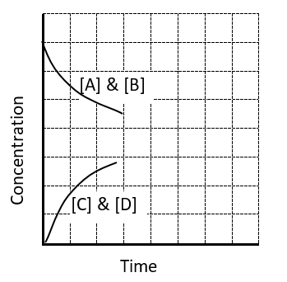
(NOTE: Even though the reaction is reversible and can occur in either direction, we still traditionally refer to the LHS as the reactants and the RHS as the products)
If we graph the progress of this reversible reaction, when starting only with reactants A and B present. At the same time that the concentrations of A and B are decreasing, the concentrations of the products, C and D, are increasing from their initial concentrations (which is usually, but not always, zero). For the reverse reaction, C and D are the reactants, so the rate of the reverse reaction will increase over time, as more C and D are present. As the reaction progresses, the rate of the forward reaction decreases, and the rate of the reverse reaction increases. Eventually, these two rates will be equal. In other words, the rate at which the products are formed is equal to the rate at which they are consumed, so no net change in concentration is occurring. A reaction has reached chemical equilibrium when the rate of the forward reaction is equal to the rate of the reverse reaction. Because the rate of the forward reaction is exactly the same as the reverse reaction the reagents are all being consumed and produced at the same rate – so the concentration of all reagents does not change. There are several very important things to note here about the conditions and properties of a system at equilibrium.
- The system must be closed, meaning no substances can enter or leave the system.
- Equilibrium is a dynamic process. Even though we do not observe any changes, both the forward and reverse reactions are still taking place.
- The rates of the forward and reverse reactions must be equal at equilibrium.
- The concentrations of the reactants and products may not be equal at the start of the reaction, and they may not be equal after equilibrium is established. However, after equilibrium is attained, the concentrations of reactants and products will remain constant.
A description of a Chemical Equilibrium
One example of a reversible reaction is the reaction of hydrogen gas and iodine vapour to form hydrogen iodide. The forward and reverse reactions can be written as follows.
Forward reaction: H_{2(g)} + I_{2(g)} → 2HI_{(g)}
Reverse reaction: 2HI_{(g)} → H_{2(g)} + I_{2(g)}
The two reactions can be combined into one equation by the use of a double arrow.
H_{2(g)} + I_{2(g)} ⇌ 2HI_{(g)}
The double arrow indicates that the reaction is reversible.
When hydrogen and iodine gases are mixed in a sealed container, they begin to react and form hydrogen iodide. At first, only the forward reaction occurs because no HI is present. As the forward reaction proceeds, it begins to slow down as the concentrations of H₂ and I₂ decrease. As soon as some HI has formed, it begins to decompose back into H₂ and I₂. The rate of the reverse reaction starts out slow because the concentration of HI is low. Gradually, the rate of the forward reaction decreases, while the rate of the reverse reaction increases. When the rates of the forward and reverse reactions have become equal to one another, equilibrium has been established and the concentrations of the reagents does not change from this point forward. If the conc of the reactants is very high at equilibrium, the equilibrium is said to “far to the left”, or “strongly favours the reactants”. If the conc of the products is very high at equilibrium, the equilibrium is said to “far to the right”, or “strongly favours the products”.
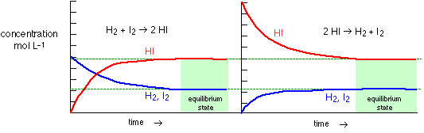
The concentration graphs below are a very common way to show reactions establishing equilibrium. Shown in the figure below are the changes in the concentrations of H₂, I₂, and HI for two different initial reaction mixtures. Chemical equilibrium can be attained whether the reaction begins with all reactants and no products, all products and no reactants, or some of both.
HI/H₂/I₂
If all reagents initially have the same conc - sketch lines to show changes in conc over time.
Questions: How do you know what the concentrations of the reagents will be like at equilibrium? What would a line look like in order to establish equilibrium at these concentrations?
Predicting equilibriums - sketch lines predicting the concentration changes over time for the reversible reaction equations and equilibrium positions described below.
A and B
C and D
A + B ⇄ C + D Starting concentrations as shown, Equilibrium is far to the right (favours products).
A and B
C
A + 2B ⇄ C Starting concentrations as shown, Equilibrium is far to the right (favours products).
C
A and B
A + 2B ⇄ C Starting concentrations as shown, Equilibrium is far to the right (favours products).

C
A and B
A + 2B ⇄ C Starting concentrations as shown, Equilibrium is far to the left (favours reactants).
A and B
C and D
A + B ⇄ C + D Starting concentrations as shown, Equilibrium is far to the left (favours reactants).
A and B
C
A + 2B ⇄ C Starting concentrations as shown, Equilibrium is far to the left (favours reactants).

A, B, and C
D
A + B ⇄ C + D Starting concentrations as shown, Equilibrium is far right (favours products).
A and B
C and D
A + B ⇄ C + D Starting concentrations as shown, Equilibrium is in the middle (favours no reagents).
A and B
C and D
A + B ⇄ 2C + D Starting concentrations as shown, Equilibrium is in the middle (favours no reagents).

A, C and D
2A ⇄ C + D Starting concentrations as shown, Equilibrium is far to the right (favours products).
N₂ and NH₃
A
N₂ + 3H₂ ⇄ 2NH₃ Starting concentrations as shown, Equilibrium is far to the left (favours no reagents).
A
C and D
A ⇄ 2C + D Starting concentrations as shown, Equilibrium is far to the left (favours reactants).

